Circuit Analysis (Lab 7)
Experiment 7: Analysis of Operational Amplifiers Operations

Name: Momna Ashraf Registration No: 2025-CE-72

Date: 4-05-2026 Grade and Signature: …………………

CLO4 | Construct amplifiers with operational amplifiers.
Psychomotor/ Affective | Level1  (1) | Level2  (2-3) | Level3  (4-5) | Level4  (6-7)
Report Marks (3) |  |  | Total marks (10)

Objective
The objective of this lab is to investigate the input to output relationship for inverting and non- inverting amplifiers.

Apparatus Required

Sr. No. | Apparatus | Range | Quantity
1 | Regulated Power Supply | Standard | 1
2 | Signal Generator | Standard | 1
3 | Oscilloscope | Standard | 1
4 | Digital Multimeter | Standard | 1
5 | Breadboard & Wires | Standard | As Required
6 | Resistors | 1k Ω, 2k Ω ,3k Ω | 3
Description
Operational amplifiers can be used in two basic configurations to create amplifier circuits. One is the inverting amplifier where the output is the inverse or 180° out of phase with the input, and the other is the non-inverting amplifier where the output is in the same sense or in phase with the input.
Both operational amplifier circuits are widely used and they find applications in different areas. When an operational amplifier or op-amp is used as a non-inverting amplifier it only requires a few additional components to create a working amplifier circuit.
Pin configuration of IC 741 op amp is shown below

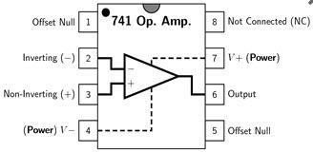
- Pin 1 is offset null.
- Pin 2 is inverting input terminal.
- Pin 3 is a non-inverting input terminal.
- Pin 4 is negative voltage supply (VCC)
- Pin 5 is offset null.
- Pin 6 is the output voltage.
- Pin 7 is positive voltage supply (+VCC)
- Pin 8 has no connection.

Precautions:
- Voltage control knob should be kept at minimum position.
- Current control knob of RPS should be kept at maximum position.
- Carefully utilize the oscilloscope channels and function generator.

Procedure for Inverting Amplifier:
- Wire up the circuit as shown in the figure below on the breadboard.
- Give the input to the inverting terminal of the op-amp and simultaneously display the input and output on the oscilloscope.
- Draw the input & output waveforms at the end of the lab.
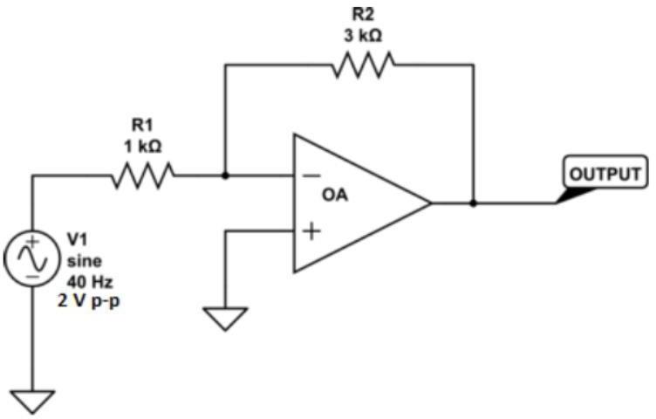

Procedure for Non-Inverting Amplifier:
- Wire up the circuit as shown in the figure below on the breadboard.
- Give the input to the non-inverting terminal of the op-amp and simultaneously display the input and output on the oscilloscope.
- Draw the input & output waveform at the end of the lab.

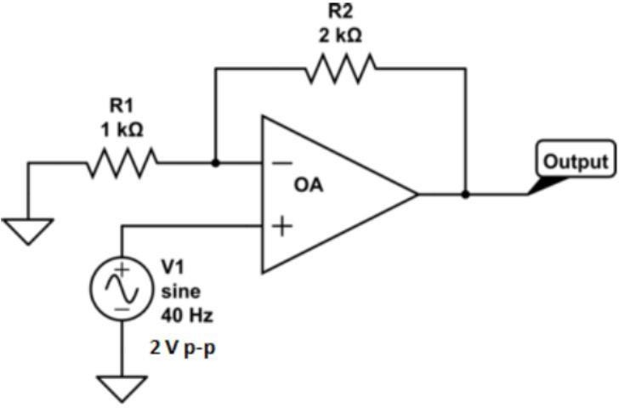

Result: 
Figure 7: Input Voltage Signal Figure 8: Inverted Output


Figure 9: Non-Inverting Output

Post Lab Questions

1. Define Inverting Amplifier
- An inverting amplifier is an operational amplifier (op-amp) configuration in which the input signal is applied to the inverting (−) terminal.
- The output signal is 180° out of phase (inverted) with respect to the input signal.
- The gain of the inverting amplifier depends on the ratio of the feedback resistor to the input resistor.

2. Define Non-Inverting Amplifier
4. A non-inverting amplifier is an op-amp configuration in which the input signal is applied to the non-inverting (+) terminal.
5. The output signal is in phase (same polarity) with the input signal.
6. It provides high input impedance and does not invert the signal.

3. Applications of Inverting Amplifier
7. Used in signal inversion applications where phase reversal is required.
8. Used in summing amplifiers and mathematical operations circuits.
9. Used in active filters and waveform shaping circuits.

4. Applications of Non-Inverting Amplifier
10. Used as a voltage follower (buffer) to provide high input impedance and low output impedance.
11. Used in amplification of weak signals without changing their phase.
12. Commonly used in audio and instrumentation systems.

5. What is Gain of an Amplifier?
13. Gain of an amplifier is the ratio of output signal amplitude to input signal amplitude.
14. It indicates how much the amplifier increases the strength of the input signal.
15. Gain can be expressed in terms of voltage, current, or power.

6. How do you calculate the gains for inverting and non-inverting amplifiers?
16. The gain of an inverting amplifier is given by:
Av = − (Rf / Rin)
17. The negative sign indicates that the output is inverted.
18. The gain of a non-inverting amplifier is given by:
Av = 1 + (Rf / Rin)

16.

17.

18.

